**Class 4 Lab questions**

#1. WAP to test whether a number entered through keyboard is ODD or EVEN.

Code:

#include <stdio.h>

int main()

{

    printf("Provide the integer:\n");

    int a285;

    scanf("%d",&a285);

    if((a285%2==0) && (a285!=0))

    {

        printf("%d is Even\n", a285);

    }

    else if((a285%2!=0) && (a285!=0))

    {printf("%d is odd",a285);}

    else{

        printf("0 is niether odd nor even!!!");

    }

    return 0;

}

Output:

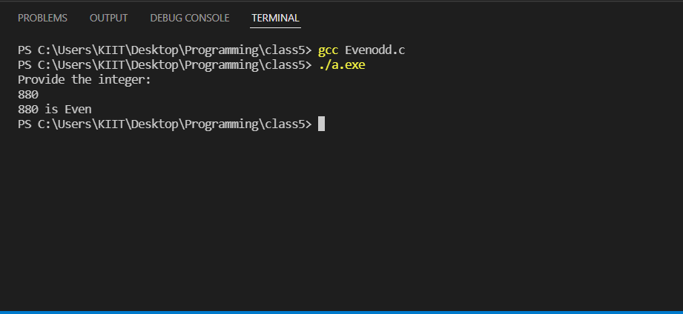

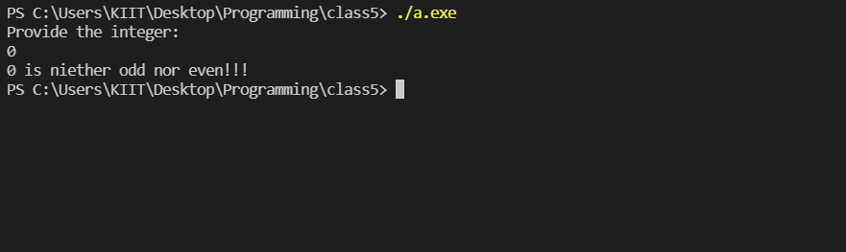

#2. WAP to input any two integers distinct and display the greater of two integers.

Code:

#include <stdio.h>

int main()

{

    printf("Provide the numbers you want to compare:\n");

    float a285,b285;

    scanf("%f%f",&a285,&b285);

    if (a285<b285) {

        printf("The larger number is %f",b285);

    }

    else if(a285>b285)

    {

        printf("The larger number is %f",a285);

    }

    else

    {printf("The numbers must be distinct!");}

    return 0;

}

Output:

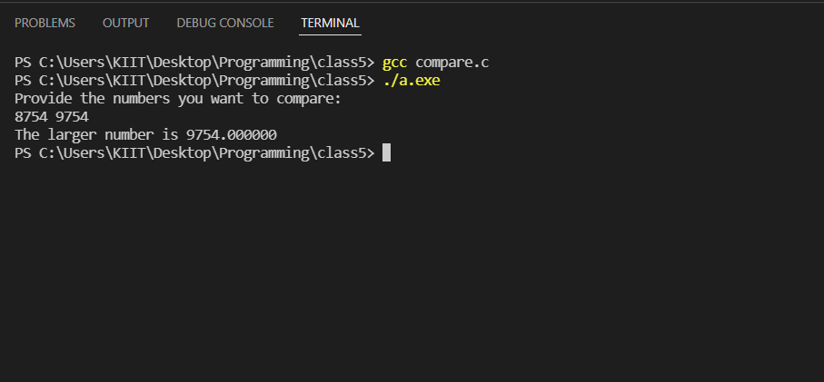

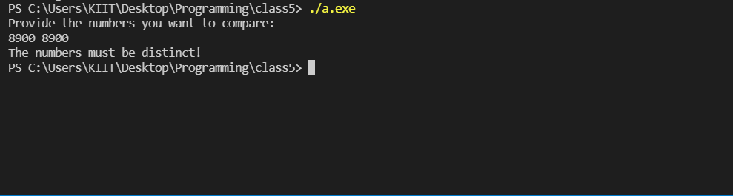

#3. WAP which takes two integer operands and one operator form the user, performs the operation and then prints the result. (Consider the operators +,-,*, /, % etc). Use switch cse.

Code:

#include <stdio.h>

int main()

{

    printf("which operation do you want to perform:\n");

    int a285,c285;

    printf("1 for addition\n");

    printf("2 for subtraction\n");

    printf("3 for division\n");

    printf("4 for multiplication\n");

    printf("5 for modulus calc\n");

    scanf("%d", &a285);

    int one285,two285;

    printf("please provide the numbers you want to operate with;\n");

    scanf("%d%d",&one285,&two285);

    switch(a285)

    {

        case 5: c285=one285%two285;

        printf("%d", c285);

        break;

        case 4: c285=one285*two285;

        printf("%d",c285);

        break;

        case 3: c285=one285/two285;

        printf("%d",c285);

        break;

        case 2: c285=one285-two285;

        printf("%d",c285);

        break;

        case 1: c285= one285+two285;

        printf("%d",c285);

        break;

        default: printf("NA");

    }

    return 0;

}

Output:

